Handling Dynamic Content Loading

What it is:
- Content that loads after page initial load
- AJAX calls, lazy loading, infinite scroll
- Elements appear/disappear based on user actions

Dynamic content: Elements that appear LATER after:
- User clicks something
- Page scrolls
- AJAX calls complete
- Data loads from server
Dynamic handling = waiting for these "late-arriving" elements that weren't there when page first loaded.
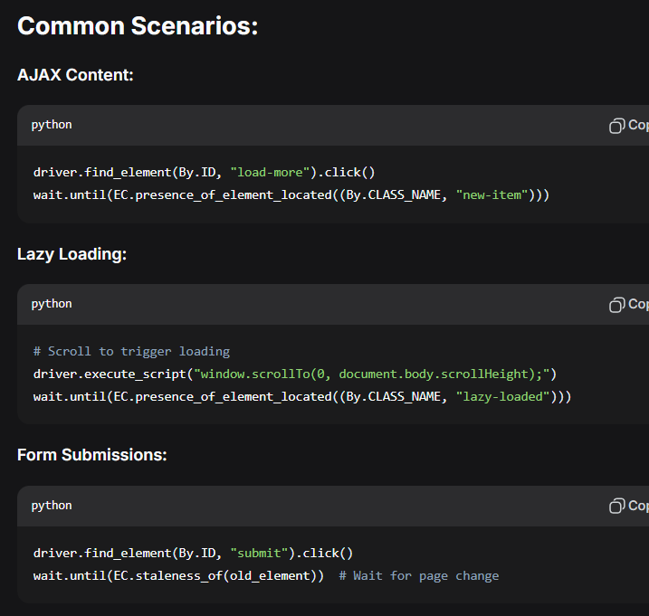

Key Points:
- Never use hardcoded time.sleep()
- Use explicit waits for all dynamic content
- Combine with custom conditions for complex scenarios

